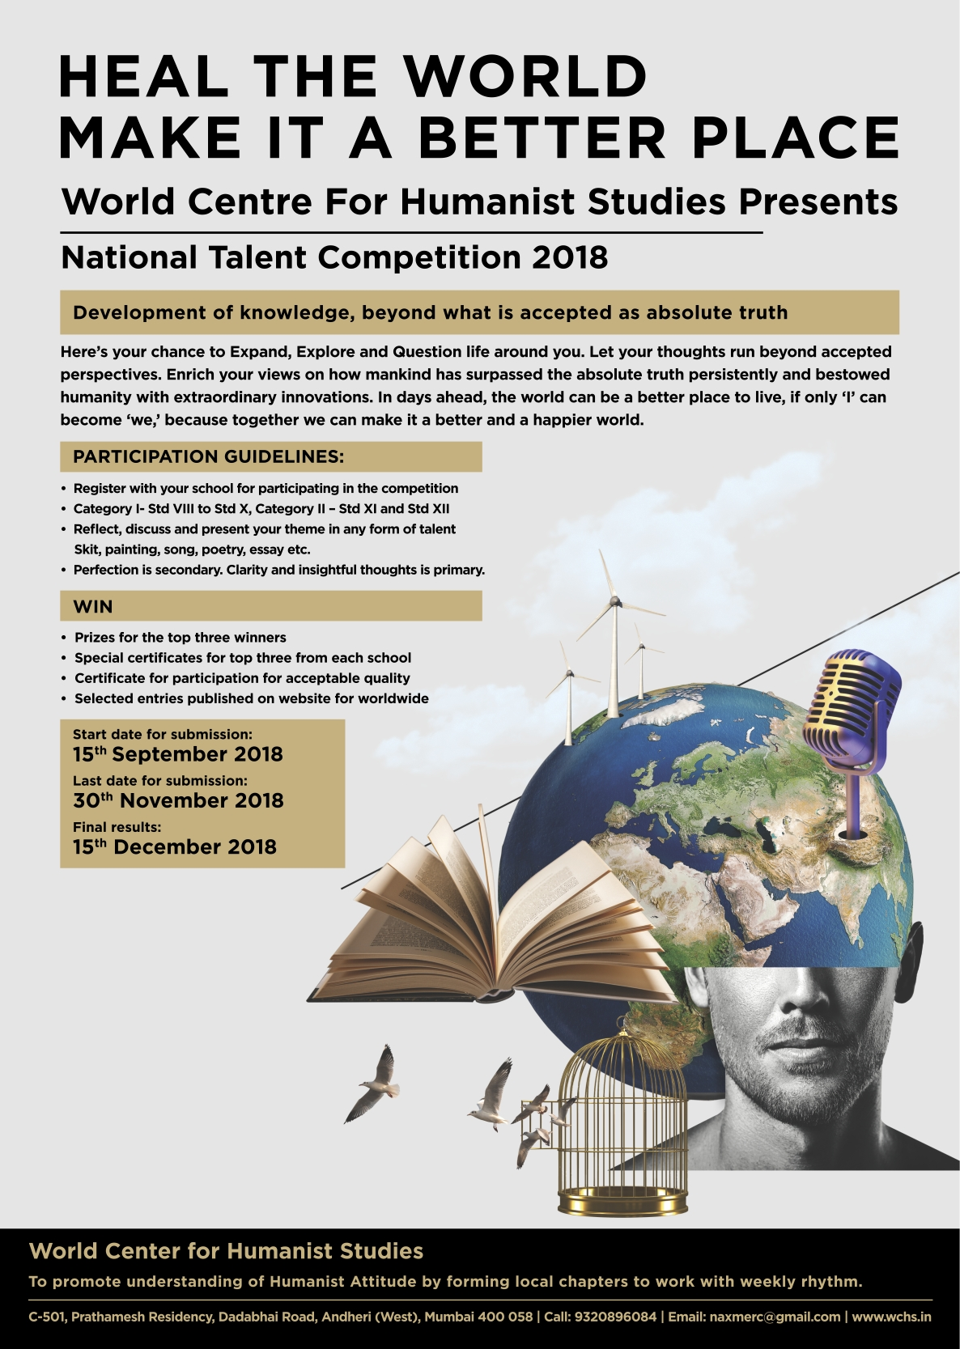

National Talent competition – 2018
“Development of knowledge beyond what is accepted as absolute truth”

Human beings have always struck a contrasting difference from other species, thus challenging what was accepted as absolute truth and that is how humanity has progressed through centuries.

It was absolute truth that :

At night there will be darkness and human being invented light
Human being can’t fly and human being invented aircrafts
Human voice can’t go beyond a distance and human being invented telephone
Women are inferior and can’t vote and human being started feminism
Slaves are slaves and should be flogged and human being stopped the system
Kings are kings and they have a right to rule and human being created democracy
Epidemics were a result of God’s wrath and human being created medicine.

Now there are another set of ideas given as absolute truth;

Humanity needs weapons Is it so? what amount of resources are wasted.
Politics is dirty is it so? after all great leaders were involved in freedom struggle
Son is better daughter Is it so? are both not human with equal potential?
Life depends on karma and destiny Is it so? or is it tying us down and stopping us from growing
American life is more valuable than Syrian Is it so? or above all is humanity
Money is the most important thing in life. Is it so? can it buy happiness and love.
Better you mind your own business is it so? or are you connected with others
Fair skin gives confidence is it so? or it is so advertised for profits of companies

These are just few examples. Observe the life around you. Identify and discuss your perspective with your family and friends. After enriching your views with these discussions, present the same in whatever form of talent that you are good at and send your entry for competition.

Entries from schools were invited in the form of any form of talent on the topic.
Last date was 30th November 2018.

Entries came in from all directions and in all forms. There were paintings, poetry, essay and skits. They reflected superb creativity, insights and reflection by the participants.

It was an extremely difficult task for the judges. Entries not selected missed by only few points.
We would congratulate all of them for participation and the brilliant performance.

The final results are as follows:

Category – I Std. VIII to Std. X
1st Prize shared by two entries
Amrita Bhadra from Army Public School Barrackpore, Kolkata
Debarghya Tapadar from Army Public School Barrackpore, Kolkata

2nd Prize shared by three entries
Muskan Mehlawat from Ajanta Public School, Gurugram
Asmita De from D.A.V. Public School, Thane
Manavdeep Singh from Vikas Bharati Public School, New Delhi

3rd Prize shared by four entries
Sandgi Warware from Central India Public School, Nagpur
Shreya Goel from ASN Senior Secondary School, Delhi
S. Sanchith from Shanthinikethana School, Bangaluru
Sakshi Singh from Cambridge Court High School, Jaipur

Category – II Std. XI and Std. XII

1st Prize Kartikey Sharma from Vikas Bharati Public School, New Delhi

2nd Prize shared by two entries
Ankur Sharma from Ryan International School, Faridabad
Gunjot Singh from Shemrock Senior Secondary School, Mohali
3rd Prize shared by two entries
Simran Singh Rathi from Bhavan Vidyalaya, Panchkula
Unitta Anna Shaji from Good Shepherd Public School & Junior College, Kottayam

Our hearty congratulations to all the winners.
Our hearty congratulations also to all others who were shortlisted at the School Level.

